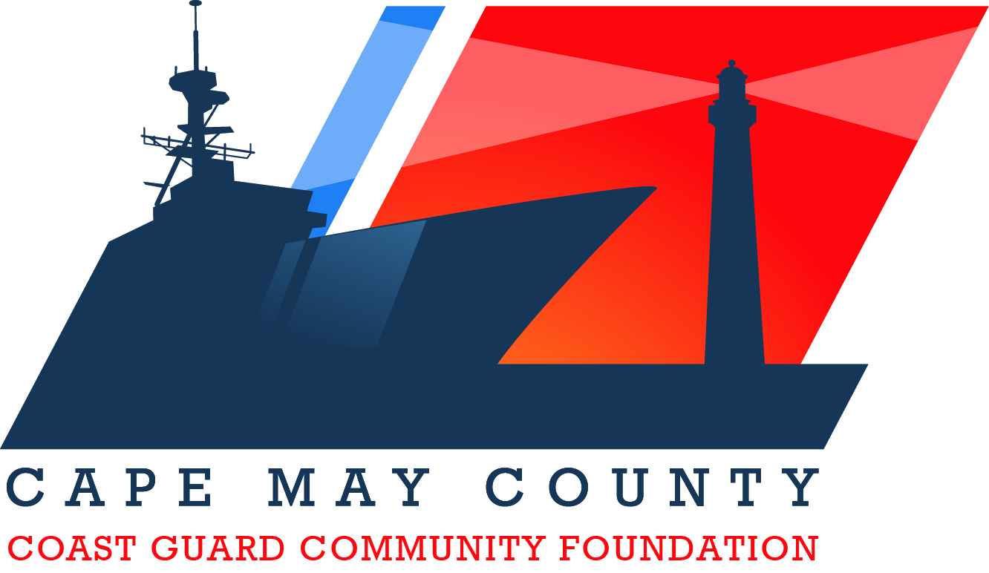

Guidelines for the Hometown Hero Award Program

- Background Information:
The Cape May County Coast Guard Community Foundation is a non-profit organization that honors Coast Guard men and women who serve our country and celebrates the county’s designation as a Coast Guard Community.

Each year the Cape May Country Coast Guard Community Foundation takes the time to delve into the local community and carefully identify those who have shown support, dedication and made a difference in unique and memorable ways. We work with the United States Coast Guard Training Center Cape May and members of the local community to identify these exceptional candidates.

- Selection Criteria:
- A person or organization active in the Cape May County community that goes above the call of duty to embrace the Coast Guard as part of the Cape May County community.
- A United States Coast Guard member or a member of their family whose actions help to connect the Cape May County community and the United States Coast Guard. This individual exemplifies courage, kindness, and unselfish character which contributes significantly to the betterment of Cape May County.

3. The Selection Process:
- Requests for nomination will be published to the general public and Coast Guard members and their families through regular communication channels (i.e., print, electronic, etc.).
- A Selection Committee shall be appointed by the Cape May County Coast Guard Community Foundation Board of Trustees on an annual basis.
- Nominations must be submitted electronically or by mail by the September 30th deadline.
- The Cape May County Coast Guard Community Foundation Board of Trustees shall approve the awardee(s) no later than October 19th.
- The award recipient(s) will be notified prior to the presentation of the award at a soon to be determined event or date.

Note: All dates are subject to revision and change.

Hometown Hero Award Nomination Form

Nominee Information

Name: ______________________________________________________

Email Address: _________________________________________________

Phone Number: ________________________________________________

Please provide a description of the Nominee’s actions below which contribute/have contributed to the betterment of the relationship between Cape May County and the United States Coast Guard. The description should include examples of any accomplishments and positive outcomes.

*Feel free to attach additional documentation to support the nomination.

Nominator Information

Name: ______________________________________________________

Email Address: _________________________________________________

Phone Number: _______________________________________________

Please complete form above and mail to address below no later than September 15, 2022 to ensure receipt by Friday, September 30, 2022

Cape May County Coast Guard Community Foundation
P.O. Box 1365, Rio Grande NJ 08242
Or Email to
HometownHero@coastguardcommunity.org

